Exp-8: Develop an Online Learning Platform in jira

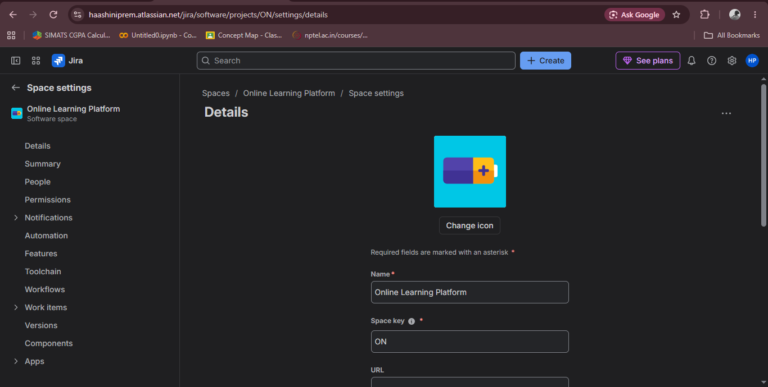
Step 1 – Create the new project in the spaces and choose the platform

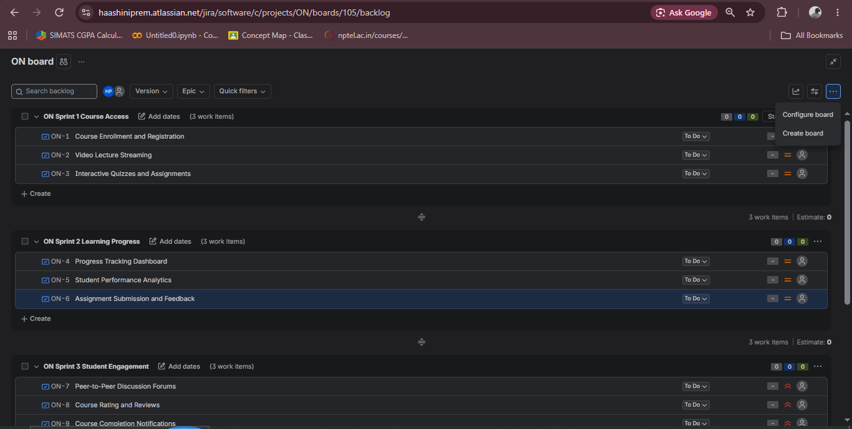
Step 2 – Create the sprints and keep another backlog as extra tasks

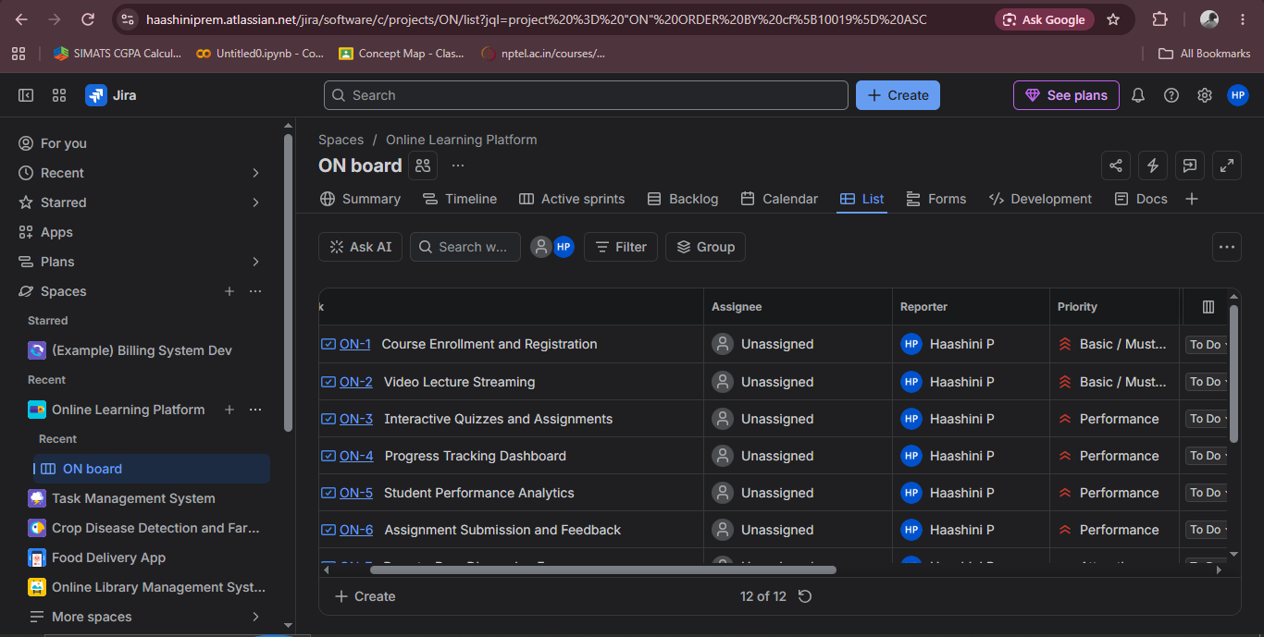
Step 3 – Create the priority for Kano and set their priority

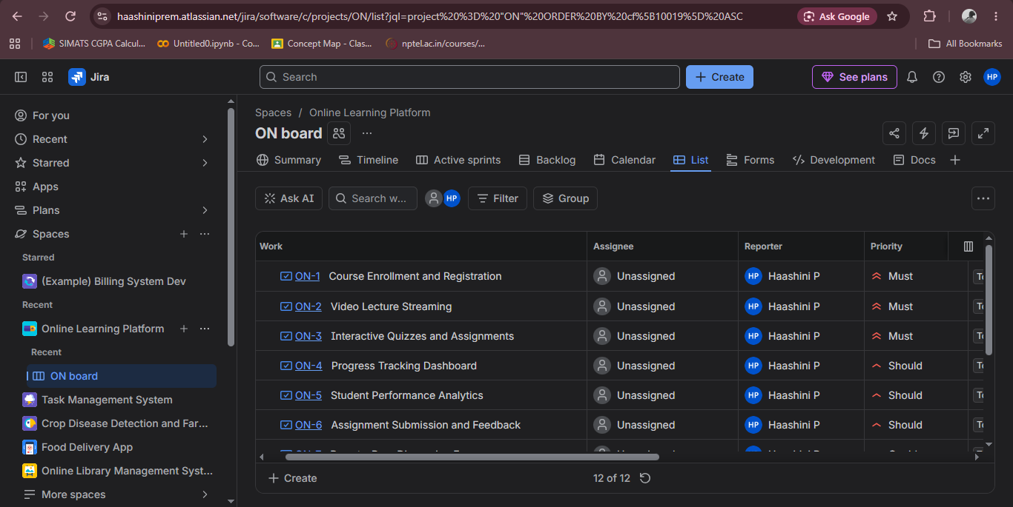
Step 4 - Create the priority for Moscow and set their priority
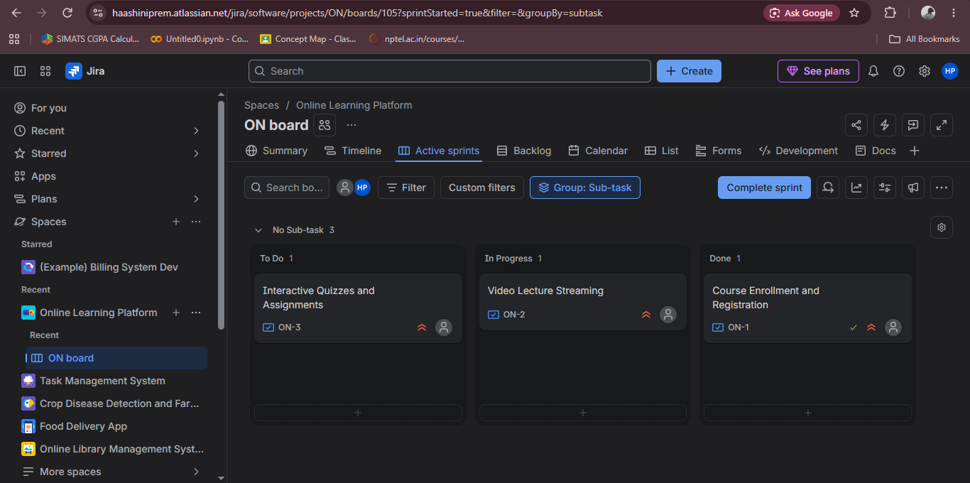
Step 5 – Start the sprint and display them in order

